Evidence for Analysis and Design Unit.

Pauline Cairns

E21

* + 1. **Use case Diagram**

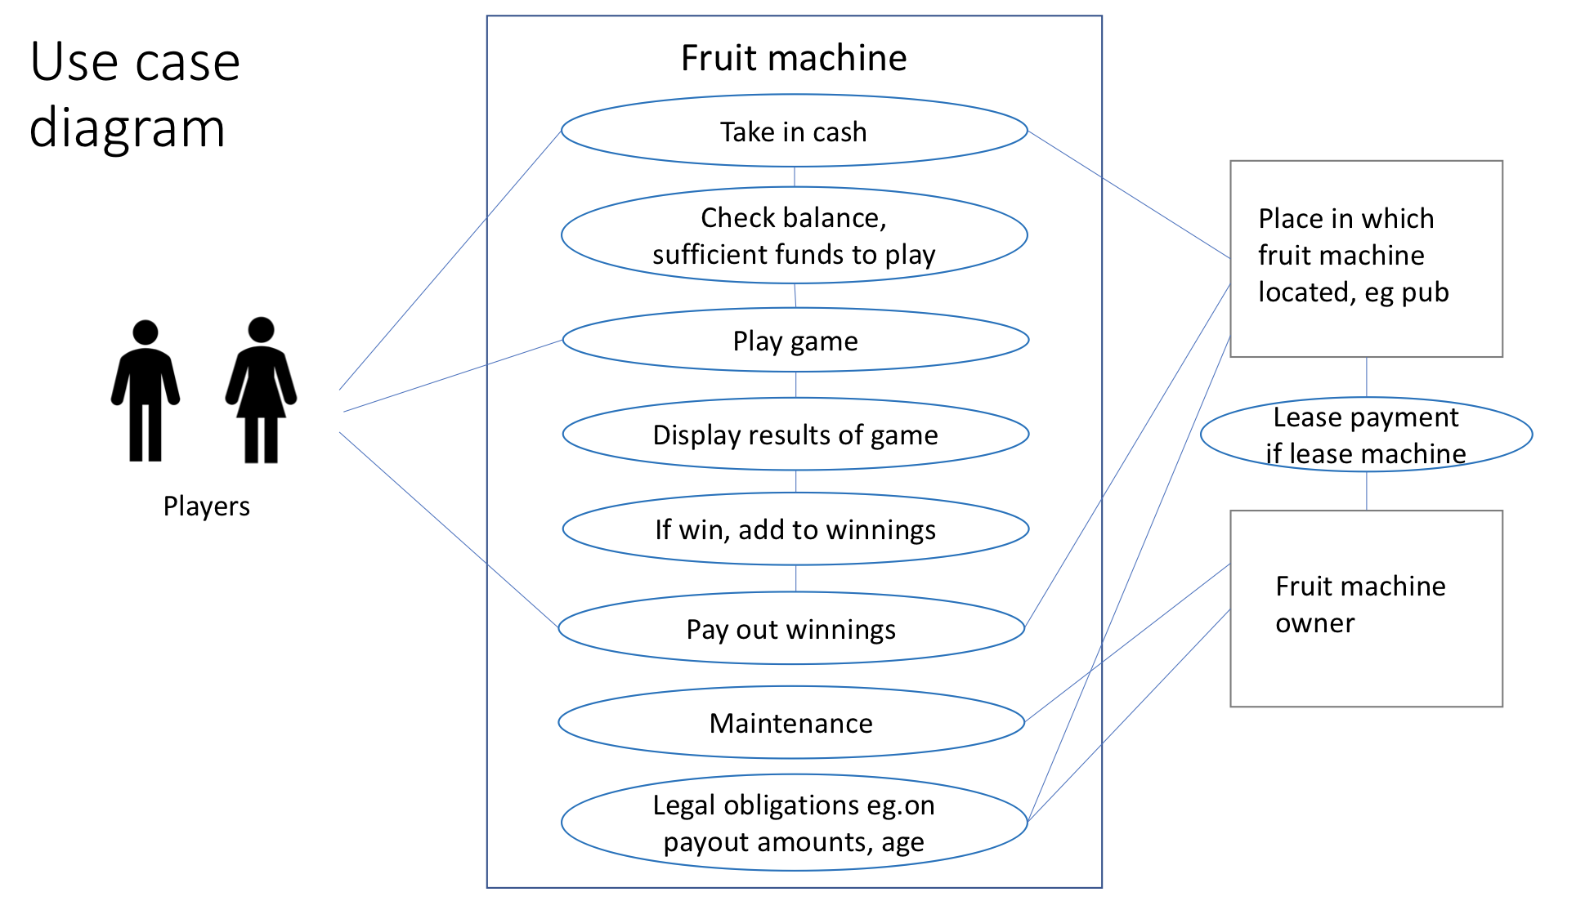

* + 1. **Class diagram**



* + 1. **Object diagram**



Evidence for unit

* + 1. **Activity diagram**



Evidence for unit

* + 1. **Inheritance diagram**



Evidence for unit

* + 1. **Implementations Constraints**

|  |  |  |
| --- | --- | --- |
|  | **Constraint and possible effect** | **Solution** |
| **Hardware and software platforms** |  |  |
| **Performance requirements** |  |  |
| **Persistent storage and transactions** |  |  |
| **Budgets** |  |  |
| **Time** |  |  |